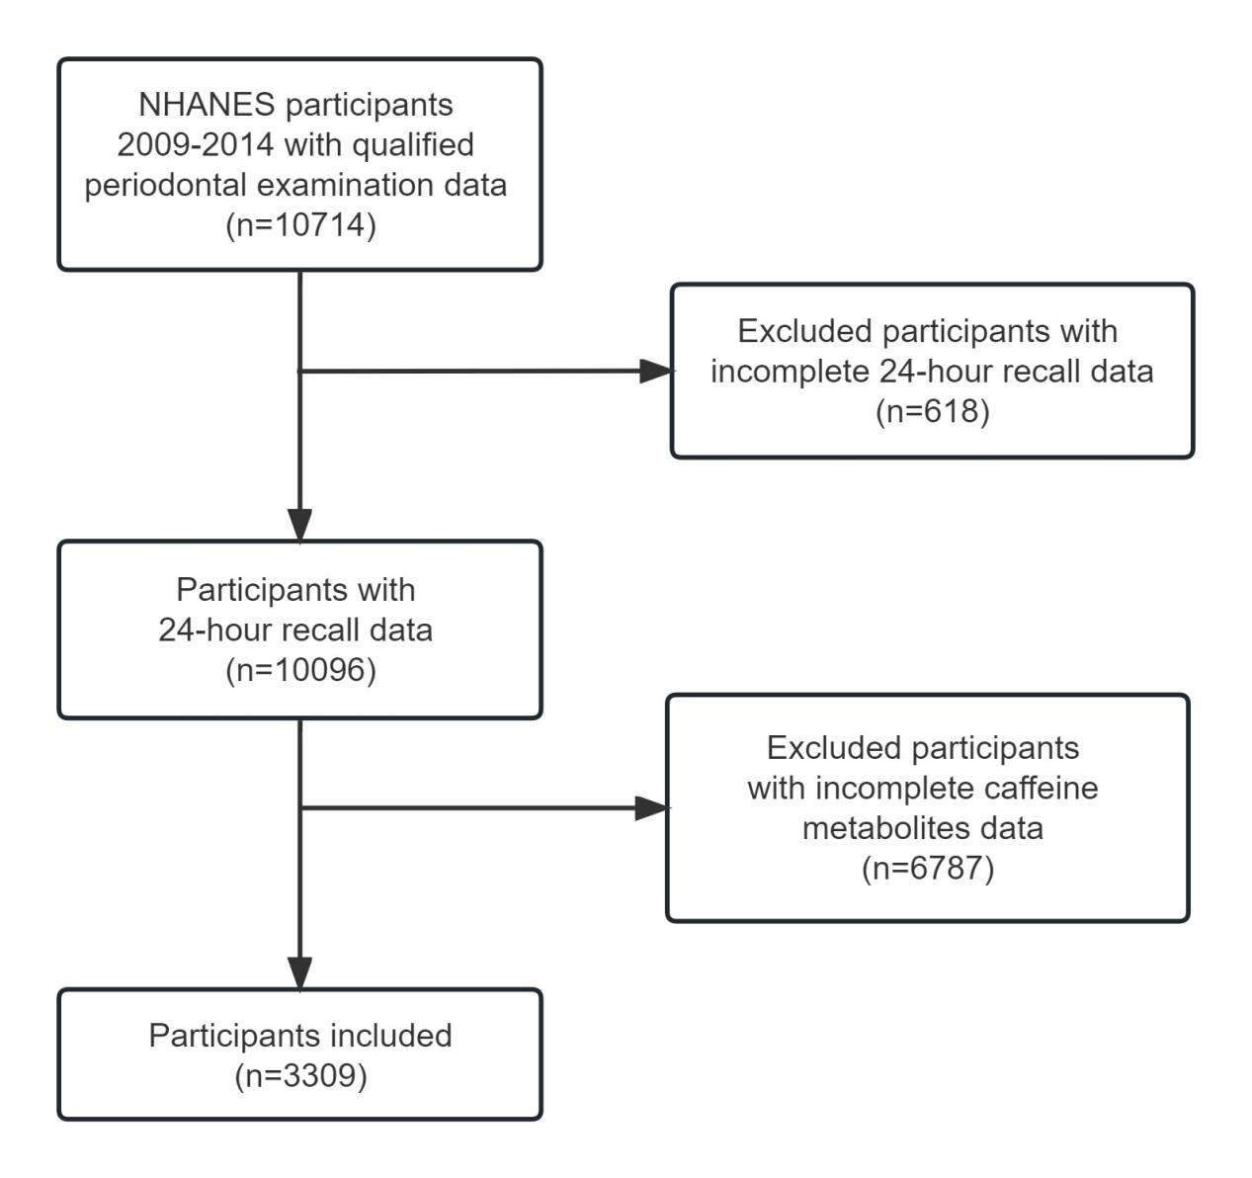

Supplementary Figure 1 Flowchart for screening participants